Task 4-Kupujem Prodajem

# *Owner:*

From the owner's side of Kupujem Prodajem the goal is to connect users who will buy or sell an item through a completely free(basic) use of the site. On the other hand, using expert advice (psychologists) they have an unlimited space to advertise because the human brain is set to purchase when it is on the page Kupujem Prodajem. Advertising does not bother them,they are even desirable, while this can’t be said for social networks like Facebook ,Instagram…

In addition to advertisements, there is the possibility of paying for ads to be highlighted and to be re-published after 30 days.

Since they have 40000 ads per day, the opportunities and wishes of the users to point out their ad are great and therefore the possibility of extra profit and good business.

Another good business idea is investing in new technologies where they have improved the classification of ads by category by implementing AI. By Human error 10% of ads go to the wrong category where the AI corrects it.

***Buyer***:

From the buyer side quality ,price and variety of articles are the main reasons for such popularity.

Some products are significantly more expensive in the store but on Kupujem Prodajem. The buyer does not care if what he wants came illegal into the country if it is cheaper.

The buyer wants to buy a product as cheaply as possible. But there is a big risk is the product genuine, functional, or just as the seller presented and advertised.

There is a possibility to comment and rate the seller, but this is not a protection for the buyer it’s only a warning to other customers not to buy from that seller as it is not safe.

***Seller***:

From the sellers side besides a free advertising / sales space have the opportunity to maximize the profit, which is the main feature of the gray economy that rules on Kupujem Prodajem(Serbia). Both sellers and buyers do not have to pay taxes.

They can even sell goods that are illegally imported into the country.

Products are sold at purchase prices and profit is the amount of taxes they did not pay when they imported goods. Of course not all seller are like that.

Some of them are selling used things to return a portion of the money they invested some time ago in those same things they are selling.

Often there is a fraud(sends the wrong product and does not want to return the money) and that is a short-term profit, while serious sellers will do all to get a good comment and therefore a recommendation for new customers and new sales.

Suggestions to improve website:

***Improve search criteria:***

1. add criteria : name of the seller

E.g. Customer purchased one ski pants from seller some time ago and he didn’t add him to favorites (“Pratim”). Customer wants to find that seller again in order to check his offer now. Currently he do not have possibility to search seller by name, he needs to search products in order to find the seller.

1. add criteria: phone number of the seller

E.g. Customer tried to search seller by name typing name “Bojan” but he could not find him because seller is registered as “Boki”. But if he types his phone number it will be fastest way to find him.

1. search criteria **Price** should be in two lines – one for price in EUR and one for price in RSD. When user is typing value in one currency (for e.g. 10 eur), website should automatically calculate the price in other currency (e.g. 1,179.38 din )

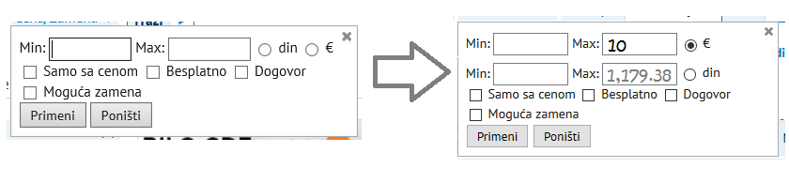

***Improve website design:***

1. articles should be listed in less bigger groups, then to subgroups and with picture icon. This will improve website design and provide more space for comercials.

E.g. Three groups : 1.Cars, 2.Cars/Spare parts and tools and 3.Cars/Equipment should be listed into one group: Cars/Spare parts/Equipment. After clicking to icon, user will choose one of three subgroups. Possibility to choose more then one group will be also useful.

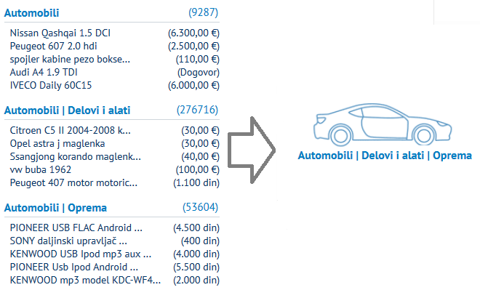

1. remove duplicate of “Trazi” button:

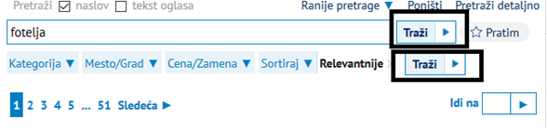

1. Logout should be bellow the profile information
2. “Pocetna” can be removed because Kupujemprodajem logo is home button
3. “Pretrazi detaljno” should be removed from header line, because the same button exists in search criteria

